APPENDIX B

PHOTOGRAPHIC RECORD

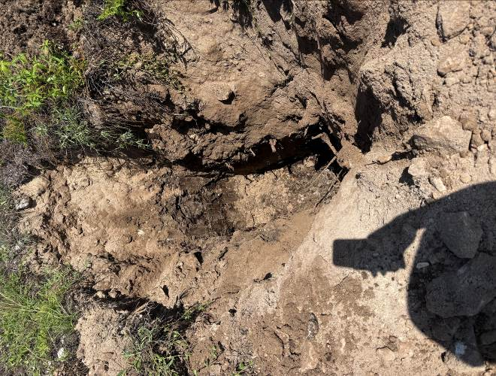  Photo 1 Trial Pit No.1 Dug. | 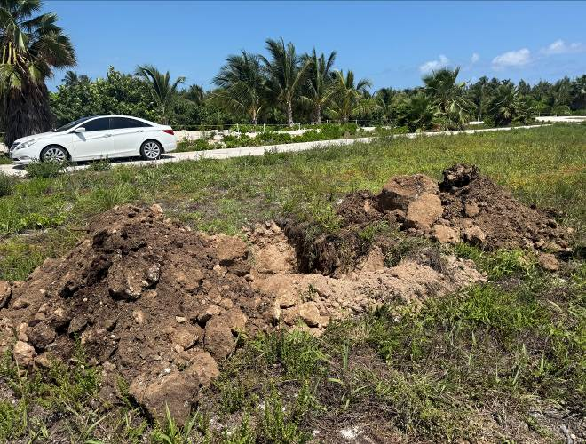  Photo 2 – Trial Pit No. 1 Spoils.
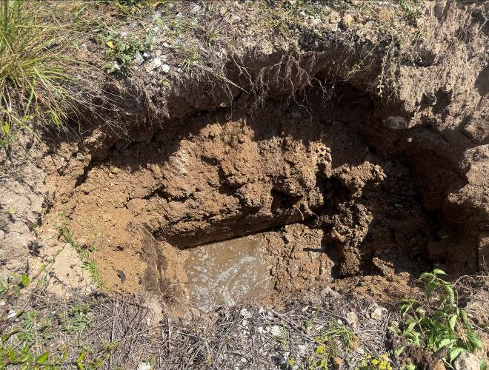  Photo 3 – Trial Pit No. 2 Dug. | 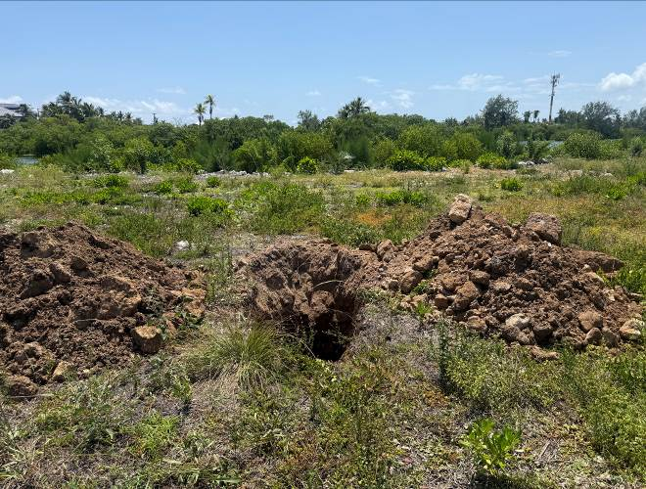  Photo 4 – Trial Pit No. 2 Spoils.

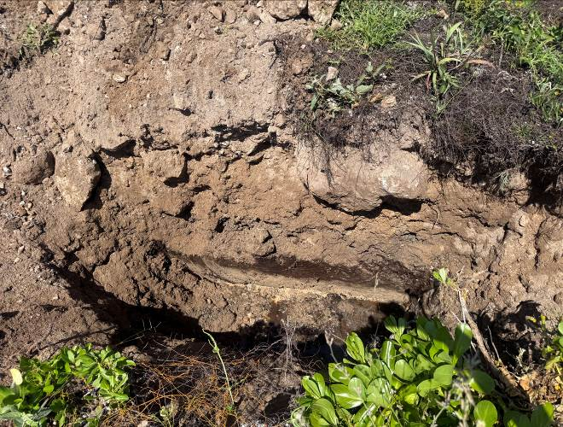  Photo 5 Trial Pit No. 3 Dug. | 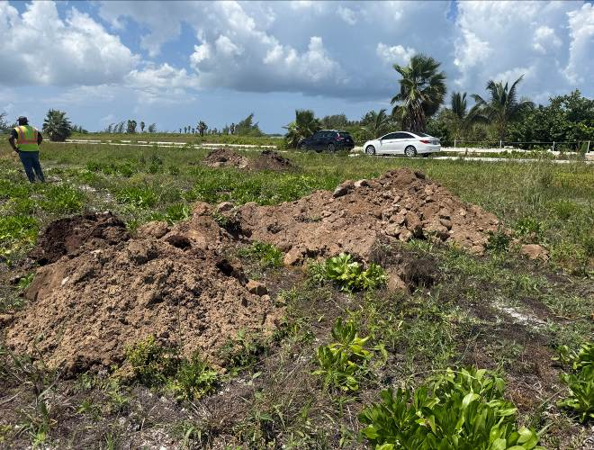  Photo 6 – Trial Pit No. 3 Spoils.
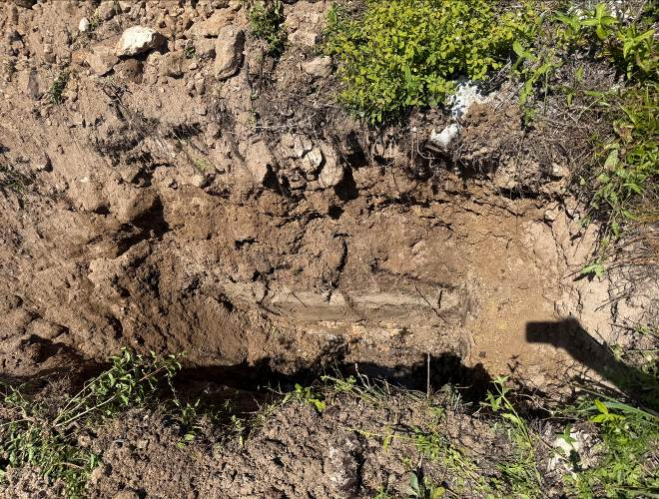  Photo 7 – Trial Pit No. 4 Dug. | 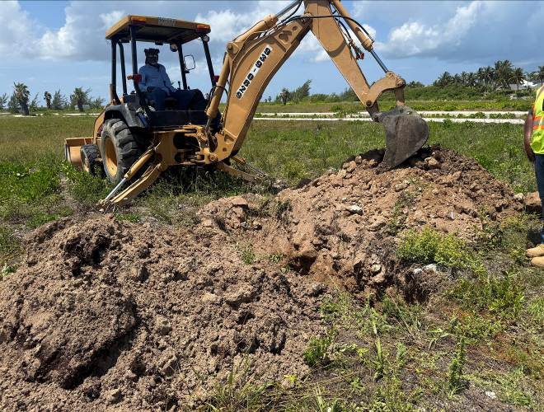  Photo 8 – Trial Pit No. 4 Spoils.

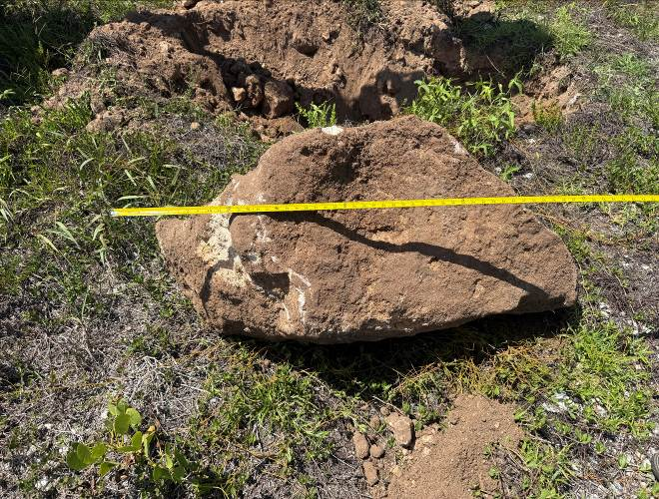  Photo 9 Trial Pit No.1 Boulder 4’-3” | 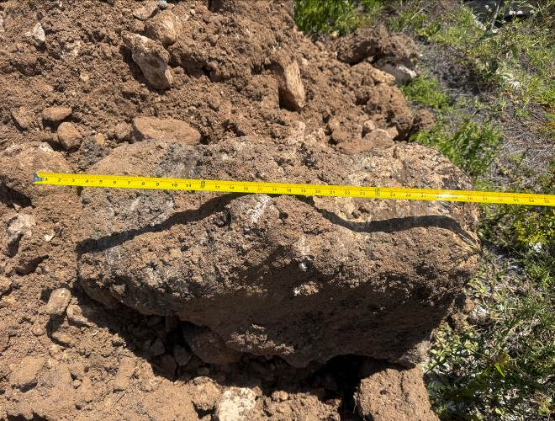  Photo 10 – Trial Pit No. 2 Boulder.
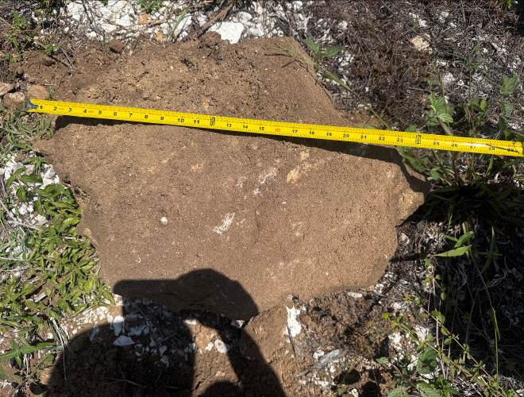  Photo 11 – Trial Pit No. 3 Boulder. | 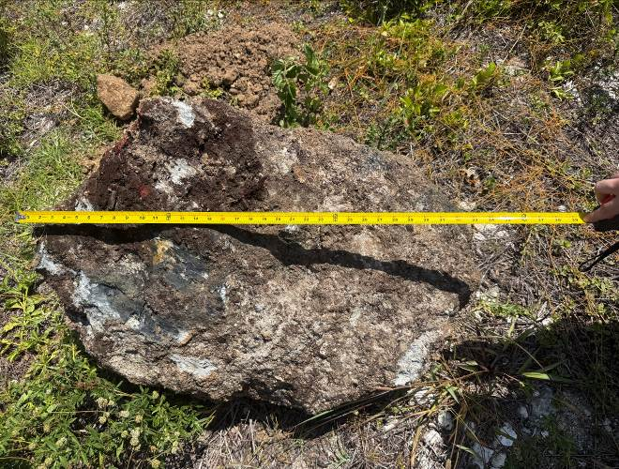  Photo 12 – Trial Pit No. 4 Boulder

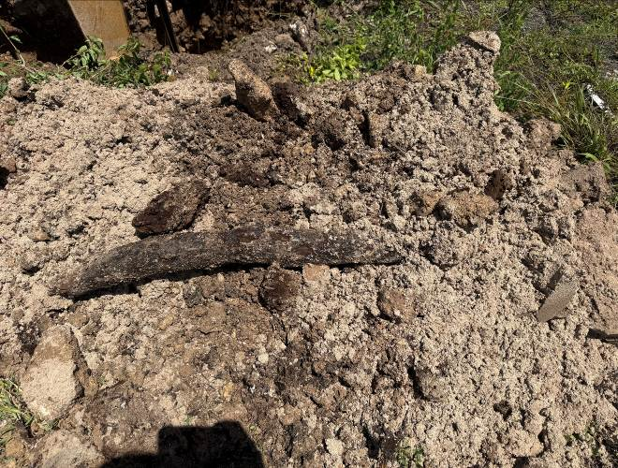  Photo 13 Trial Pit No.4 Branch 4” dia. | 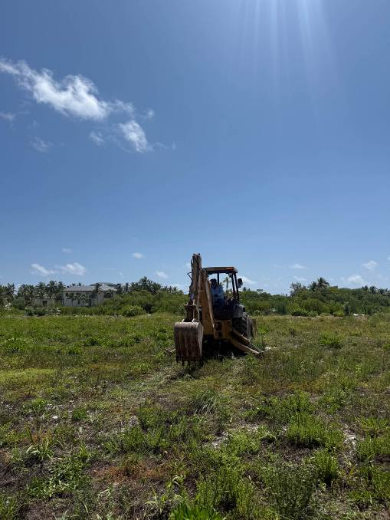  Photo 14 – Excavator on Site Facing East.

